Year 3/4 Tuesday 19th May

This Photo by Unknown Author is licensed under CC BY-SA | Where do I do my work | Topic | Instructions
 |  | Reading | 15 minutes read to yourself, family member or pet
 | 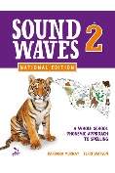 | Spelling | 20 mins Unit 4-complete one page
 | 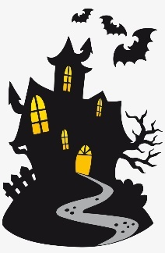 | Writing-Story settings | Complete the page in your book
 | Break
 | 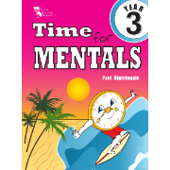 | Maths Mentals | 2 columns and please mark
 | 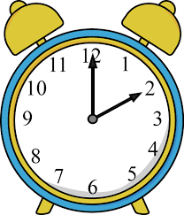 |  | If you are at home with technology watch  https://youtu.be/h6RNkQ7lU8Y then  For everyone please complete your sheet on time for today
 |  | Activity-fitness | https://www.youtube.com/watch?time_continue=6&v=6JPVKD_UT-Q&feature=emb_logo  If you are at school please choose activities from your fitness suggestions in your booklets for 15 minutes
 | Break
 | 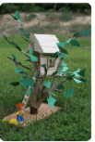 | Project | Continue on your tree house

Year 3/4 Wednesday 20th May

This Photo by Unknown Author is licensed under CC BY-SA | Where do I do my work | Topic | Instructions
 |  | Reading | 15 minutes read to yourself, family member or pet
 |  | Spelling | Complete unit 4
 |  | Story settings | Complete in your booklets. Try to use some of the descriptive word suggestions.
 | G.A.P | Fix the mistakes | Fix the mistakes. The sheet is in your booklets.
 | Break
 | 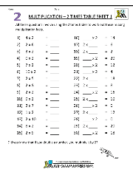 | 2 x times tables | Please do the sheets in your booklets and watch practise your 2 x tables
 |  |  | complete the maths sheet in your booklets for today
 | 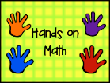 | Activity | Practise 2 times table while walking around your yard or the playground. If you know them practise one you don’t know.
 | 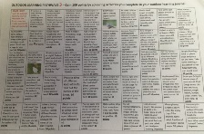 | Outdoor Learning Pathways | Continue to choose some activities. You have next week as well to complete this activity.
Thursday 21th May
=
This Photo by Unknown Author is licensed under CC BY-SA | Where do I do my work | Topic | Instructions
 |  | Reading | 15 minute read to yourself, family member or pet
 |  | spelling | Choose two activities to do today from the spelling grid
 |  | Complete a narrative  Treasure | Complete a story about the pot of gold in your booklets. Try to add lots of description about the setting.
 | 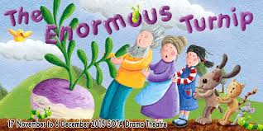 | Comprehension | Complete the comprehension on
 | Break
 | 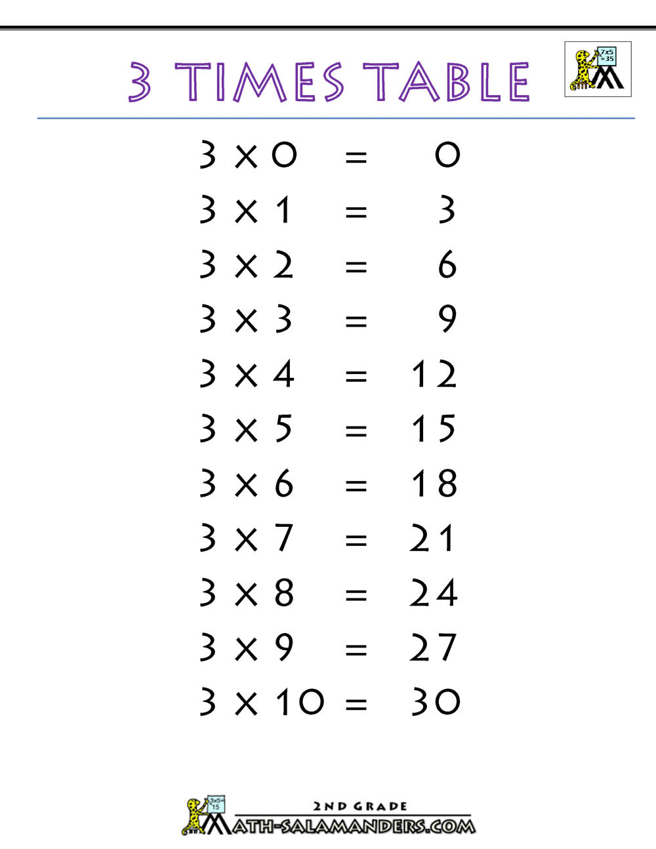 | Times tables | https://www.youtube.com/watch?v=dzVyBQ5uTbo  Can you say your three times tables? Try not skip counting but knowing your tables! Complete the three times tables sheet in your booklets.
 |  |  | complete the sheet in your booklets for today
 |  | Fitness activities | At home-https://www.youtube.com/watch?v=mhHY8mOQ5eo  At school please go and get a skipping rope and skip for fitness |  |  | At home-https://youtu.be/L_A_HjHZxfI  At school please go and get a skipping rope and skip for fitness
 | 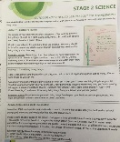 | The Living World-Science | Complete activity 2

Friday 22nd May

This Photo by Unknown Author is licensed under CC BY-SA | Where do I do my work | Topic | Instructions
Next stop on our tour is France. Here is a tour you can take if you are at home. This is the Musée d’Orsay, Paris. Some beautiful paintings here by all the masters. Some we have hanging in our room at school! Click on the little person to walk around.
https://artsandculture.google.com/partner/musee-dorsay-paris?hl=en

If you are at offline or at school try to find France on the globe and complete your artwork.
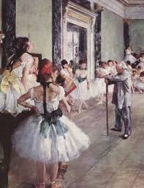

 | Break
 |  | Studyladder | Have some fun on studyladder with some maths games- for 40 minutes. Put time in the search.
 | 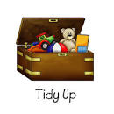 | Tidy Frydee | Get ready for Free time! Tidy that bedroom and get the thumbs up from an adult!  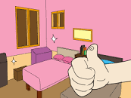
 | Break
 |  | Fun Friday

