Year 1/2 Home Learning Thursday 14th May

 | Where do I do my work? | Topic | Instructions
 |  | Reading | 15 minutes read to yourself, family member or pet
 | 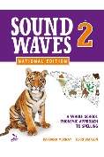 | Spelling | 20 mins Unit 5-first page today  Online: Grapheme Sort and Rhyming Words
 | 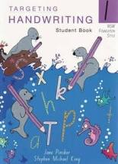 | Handwriting | Complete a page in your Handwriting book
 | Writing book | Writing | Write a story about an adventure in space. Draw a picture to go with your story.
 | Break
 | 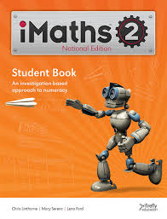 | iMaths | Year 1: Chance p128-129  Year 2: Clocks- quarter past, quarter to p106-107
 | Extra Activity | Toy Toss | Find a soft toy and a box or basket. Stand back and throw the toy into the box with your right hand 10 times. Tally up how many times you get it in. Then throw with your left hand and tally your score. Then try with your eyes closed and tally your score. Then try throwing over your head, facing away from the box. Make a graph that shows your results.
Break
 | 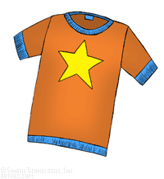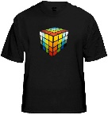  This Photo by Unknown Author is licensed under CC BY-SA-NC | Art | Design a t-shirt. You could cut out a paper t-shirt or draw it in your book. Have a go at designing a few different shirts. Who would wear your t-shirts?

Year 1/2 Home Learning Friday 15th May

 | Where do I do my work? | Topic | Instructions
 |  | Reading | 15 minutes read to yourself, family member or pet
 |  | Spelling | 20 mins Unit 5-2nd page today  Online: Word Beginnings and Endings 1, Unjumbler, Grapheme Trek
 | Scrapbook | Grammar | Add ing to these words (don’t forget to double the last consonant): skip, drip, chat, mop, chop, fit, top, brag, drag, slap.
 | Writing book | Writing | Write about what you would like to do when you grow up. You could write about a job, travelling or where you would like to live.
Break
 |  | iMaths | Year 1: Investigation 11 p28-29  Year 2: Investigation 9 p24-25
 | Extra Activity | Estimating numbers | Grab a handful of Lego or small objects. Estimate (guess) how many are in your hand. How close were you. Try again with 2 handfuls. Is there a way to estimate closely without counting every piece?
Break
 |  | Activity-fitness | Check out GetActive@Home on the NSW Education site.

Year 1/2 Home Learning Monday 18th May

 | Where do I do my work? | Topic | Instructions
 |  | Reading | 15 minutes read to yourself, family member or pet
 | Scrapbook | Spelling | 20 mins- Choose 10 list words from Unit 5 and write them in alphabetical order.  Online: Grapheme Trek
 |  | Handwriting | Complete a page in your Handwriting book
 | Writing book | Writing | Write a description of your bike. Write about the different parts and what you can do with it. Use lots of adjectives! Draw a picture.
 | Break
 |  | iMaths | Year 1: Australian Coins p86-87  Year 2: Models and symbols for fractions p74-75
 | Extra Activity | Measurement | Connect Lego pieces to make 30 cm (use a ruler to check)  Now connect Lego pieces to make 50cm  Now connect Lego pieces to make 1 metre.
Break
 | 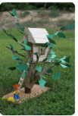 | Treehouse Project | Keep going with your tree house construction. If you have finished, answer these reflection questions:  - What did I enjoy most about the project?  - Is my tree house model similar to my design?  - How could I improve the construction of my tree house?  - What have I learnt during the tree house project?

Year 1/2 Home Learning Tuesday 19th May

 | Where do I do my work? | Topic | Instructions
 |  | Reading | 15 minutes read to yourself, family member or pet
 | Scrapbook | Spelling | 20 mins- Choose 10 list words from Unit 5, write them out and draw a picture to match the word.  Online: Make a word search with 10 list words at http://puzzlemaker.discoveryeducation.com/
 | Scrapbook | Grammar | Write the antonym (opposite) of: dark, loud, messy, easy, closed, cheap, smooth, high, late, tight
 | Writing book | Writing | Write a story about discovering a new place. It could be an island, a secret cave or a mysterious forest.
 | Break
 |  | iMaths | Year 1: Big coins little coins p88-89  Year 2: Fractions as division p76-77
 | 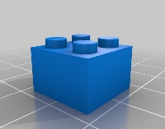  This Photo by Unknown Author is licensed under CC BY-NC | Counting groups | Choose a small piece of Lego. How many dots are there on the top? Find 3 more pieces the same size. Now how many dots?  How many dots would there be if you had 10 pieces?
Break
 | 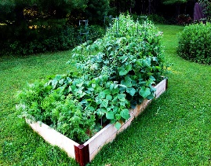  This Photo by Unknown Author is licensed under CC BY-SA-NC | Kitchen Garden | Spend the afternoon in your garden weeding, pruning, planting, watering, mulching or composting. Share a photo on Class Dojo.

